**ÖDEV1**

nums=list(range(10))

print(nums)

print(len(nums))

i=int(len(nums)/2)

print(int(i))

list1=list(range(0,i))

list2=list(range(i,2*i))

print(list2+list1)

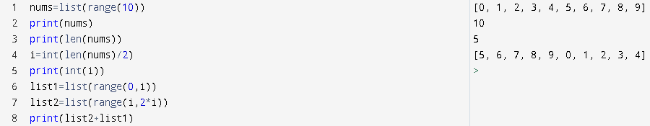

**ÖDEV2**

i = int(input("Please enter a single digit integer: "))

if i>=10:

print("invalid number")

elif i<0:

print("invalid number")

else:

i1=i

i1%=2

if i1==0:

a=0

while a<=i:

print(a)

a+=2

else:

a=0

while a<i:

print(a)

a+=2

print(i)

